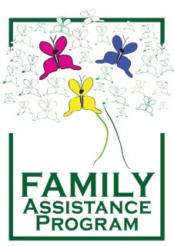
Did You Know Your Relationship
Affects Your Health?

The following questions and your answers will be kept confidential between you and the Domestic Violence Health Advocate. You do not have to answer any or all of the questions. You have the right to accept or decline the offer to receive services through the County of San Bernardino Public Health.

1 | Do you and/or your child see the doctor on a regular basis? | Yes | No | Skip
2 | Do you and/or your child have any allergies that staff should be aware of?  If so, to what? | Yes | No | Skip
3 | In the last year, have you had an annual women’s exam? (pap smear) | Yes | No | Skip
4 | Do you currently use or are you interested in obtaining birth control? | Yes | No | Skip
5 | Have you had a physical in the last year? | Yes | No | Skip
6 | At the present time, do you have any symptoms related to an STD? | Yes | No | Skip
7 | Currently, do you feel you have any health issues that need immediate treatment? | Yes | No | Skip
8 | Is your child up-to-date on their immunizations? | Yes | No | Skip
9 | At this time, do you have health insurance?  Type: Carrier: | Yes | No | Skip
10 | Are you, or your child, in immediate need of any prescriptions that you currently take on a daily basis? | Yes | No | Skip
11 | Your health care appointment will be within 3 to 5 business days maximum, is this time frame acceptable or do you have an immediate medical need? | Yes | No | Skip

Staff Use Only:

Observation of Health Issues: | Appointment Information or Declined Appointment Signature

